STEP:1 SET UP PAYPAL-BUSSINESS ACCOUNT

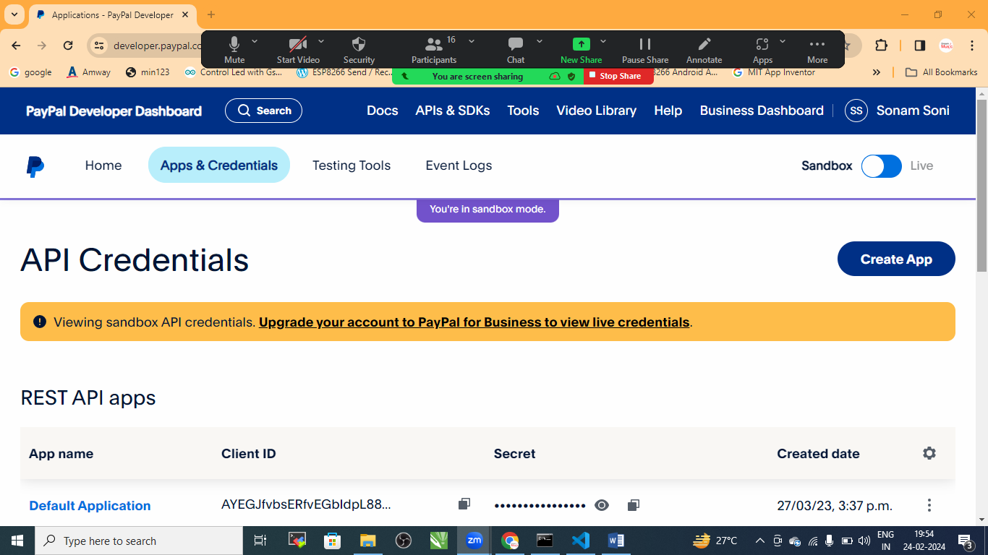

STEP:2 create app

Provide details And Generate KEY

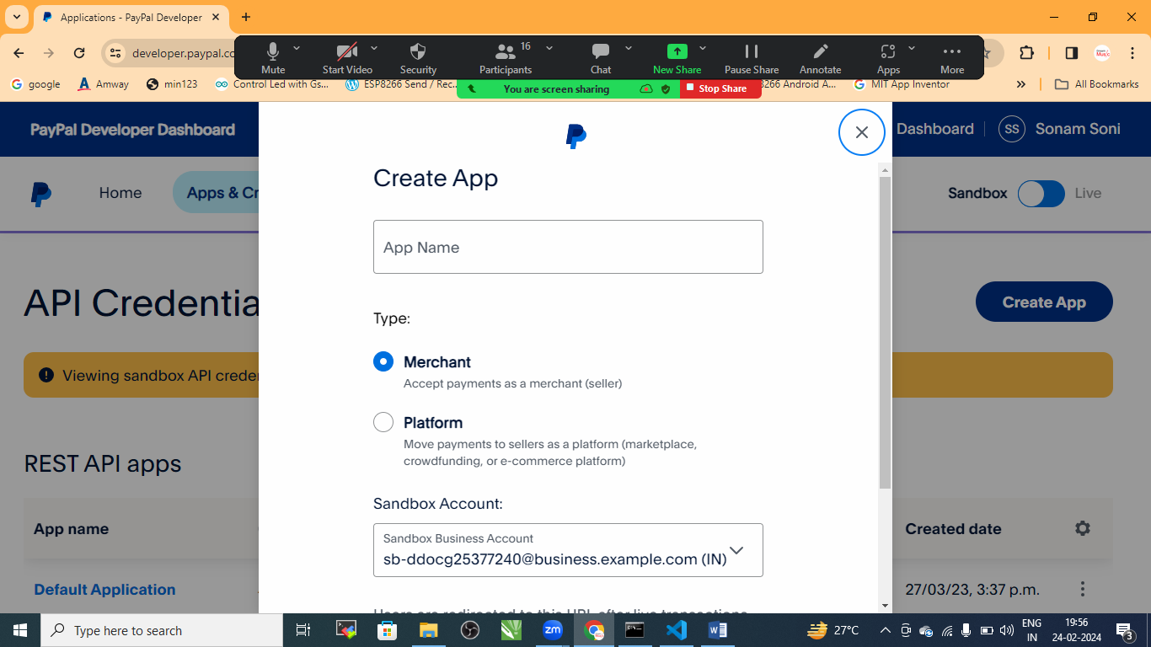

STEP:3 COPY THE CLIENT ID AND SECREAT KEY

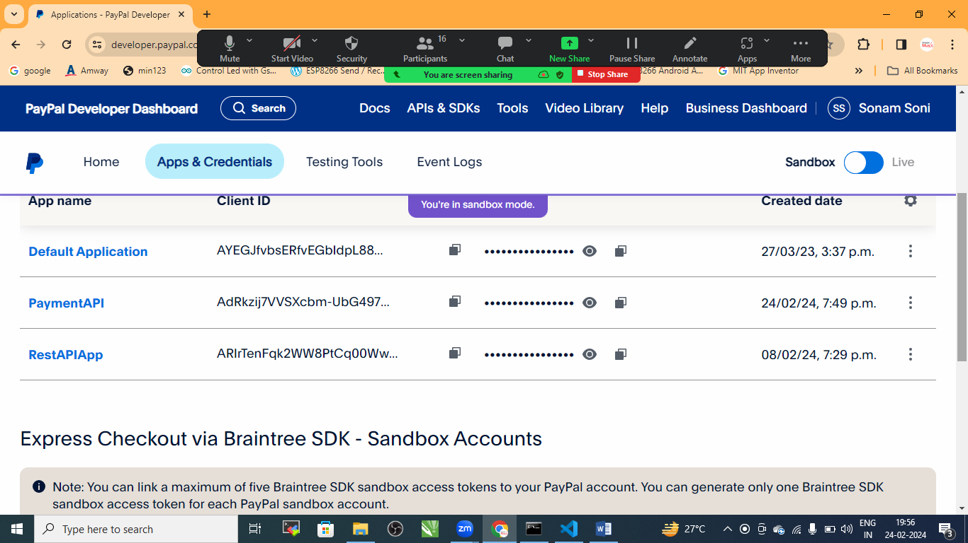

STEP:4 Create NODE-EXPRESS API

* INSTALL PAYPAL AND EXPRESS

